For data visualization of the given csv file. We will start by taking a csv file from any website. Later we will login in DataBricks and upload the csv file in the table and copy the path from it and write the code as shown below.

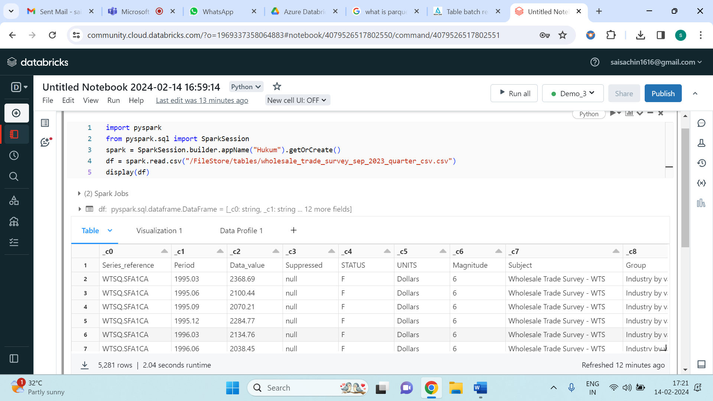

After execution of the code, you will get the resulted table as shown in the above. Click on (+) and select “Visualization” and select Visualization type and choose the ‘X’ column and ‘Y’ column and also you can choose the “Group by” (Its optional) and save it. The below image shows the data visualization:

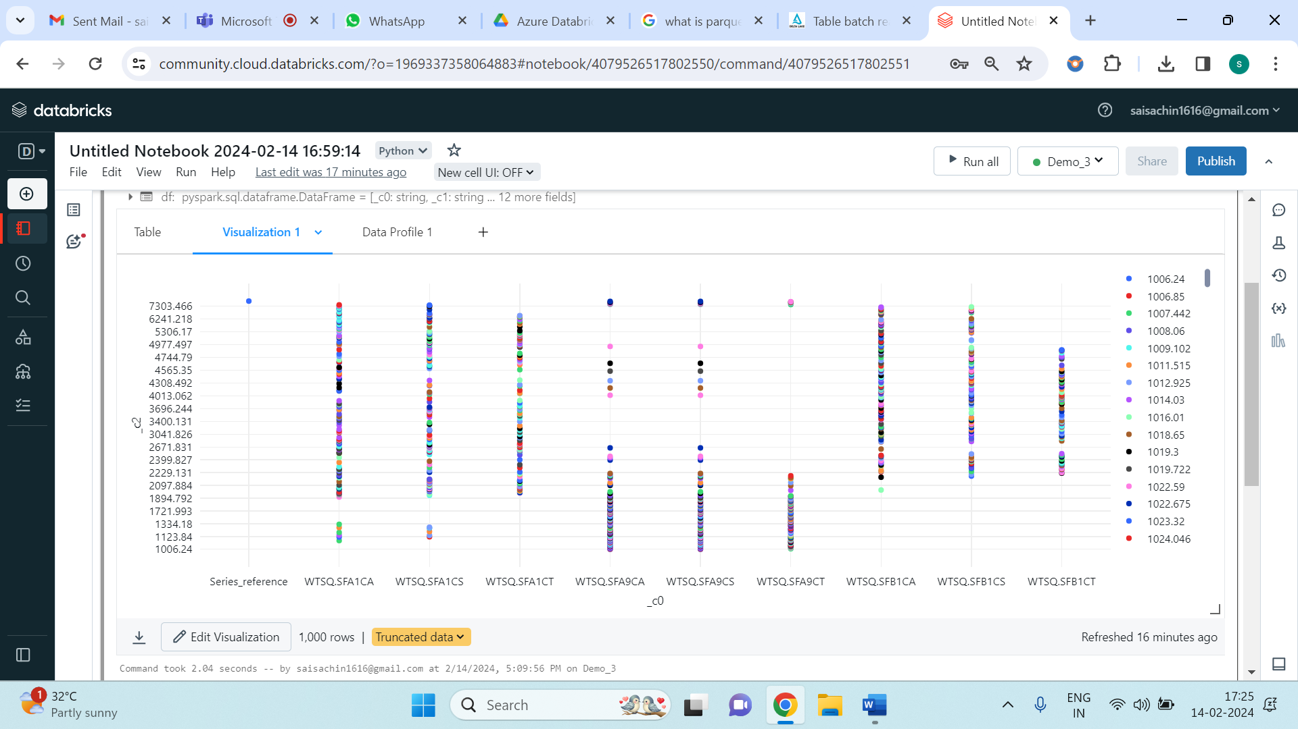

Also, we can observe Data Profile and the image is shown below:

